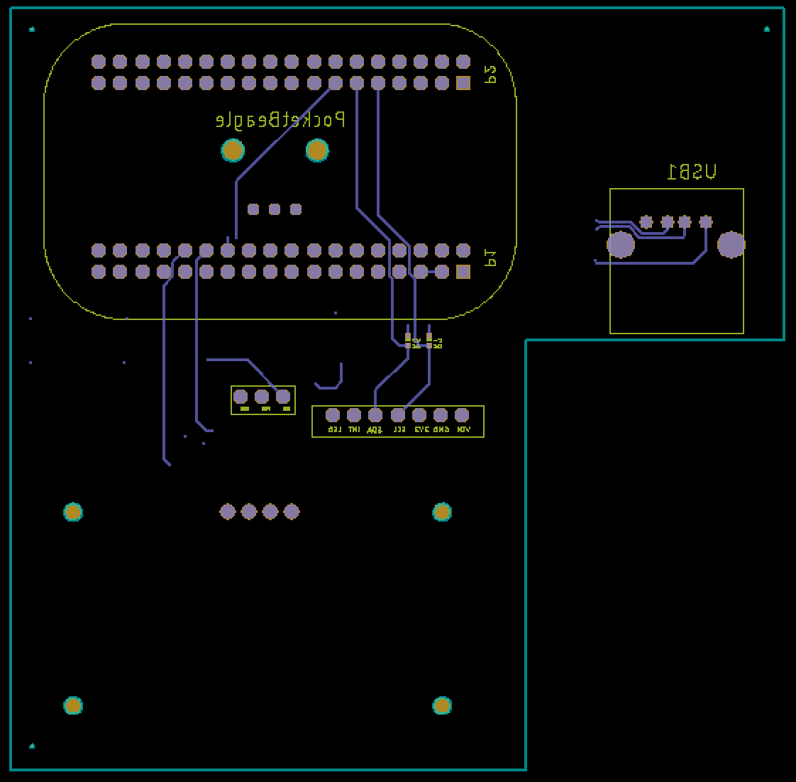

Figure 1: Bottom Layer Screenshot

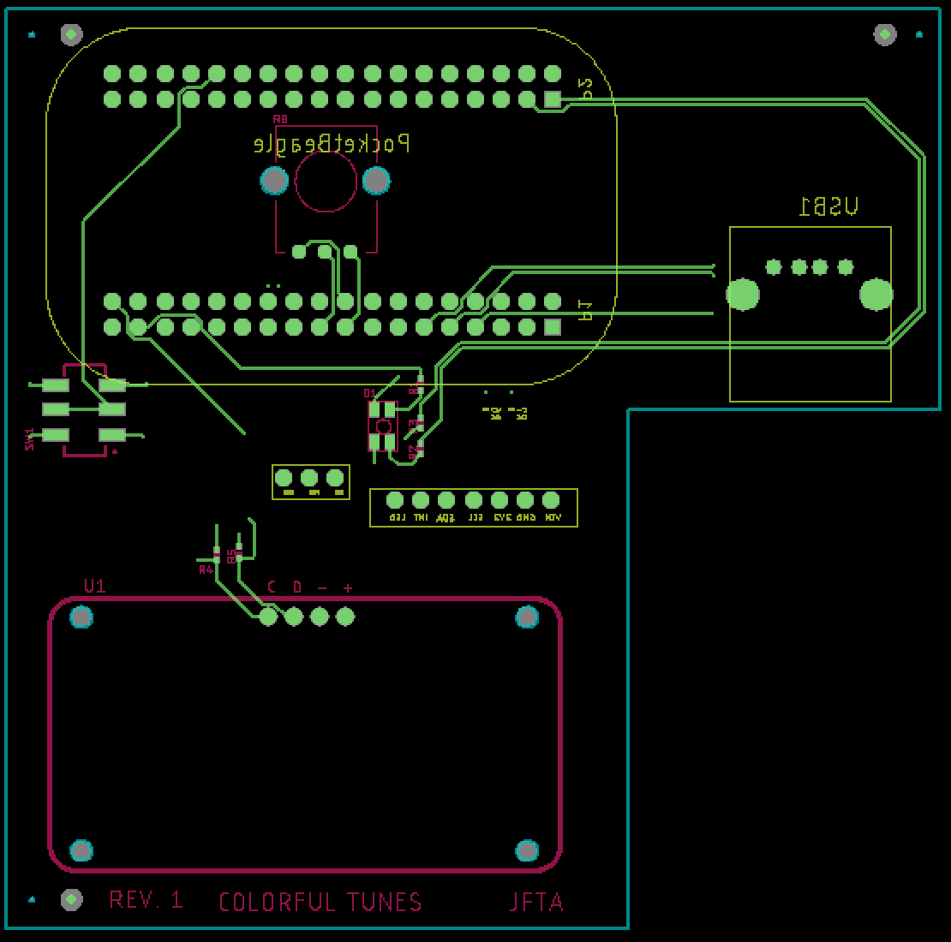

Figure 2: Top Layer Screenshot